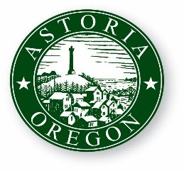
AGENDA

ASTORIA CITY COUNCIL WORK SESSION
WEDNESDAY, SEPTEMBER 12, 2018
9:00 AM
2nd Floor Council Chambers
1095 Duane Street Astoria OR 97103

- CALL TO ORDER

- ROLL CALL

- CHANGES TO THE AGENDA

- Discussion about Banning Plastic Bags in Astoria

- Policy Discussion regarding Dump Station

- WaterFRONT BRIDGES UPDATE

- ADJOURNMENT

